**CHAPTER 1: INTRODUCING FLUTTER AND GETTING STARTED**

In the world of application development, creating software that works seamlessly across multiple platforms is a common challenge. Developers often face the dilemma of building separate applications for Android, iOS, web, and desktop, resulting in increased time and resources. With its rich feature set, intuitive design principles, and robust performance, Flutter has become a game-changer in the development landscape.

Starting with Flutter is a straightforward process, even for beginners. The journey begins with setting up the development environment and exploring the framework’s rich ecosystem.In the rapidly evolving world of technology, the demand for cross-platform applications is higher than ever. Developers face the challenge of building applications that run seamlessly on multiple platforms while maintaining performance and visual consistency.

**INSTALLING FLUTTER SDK**

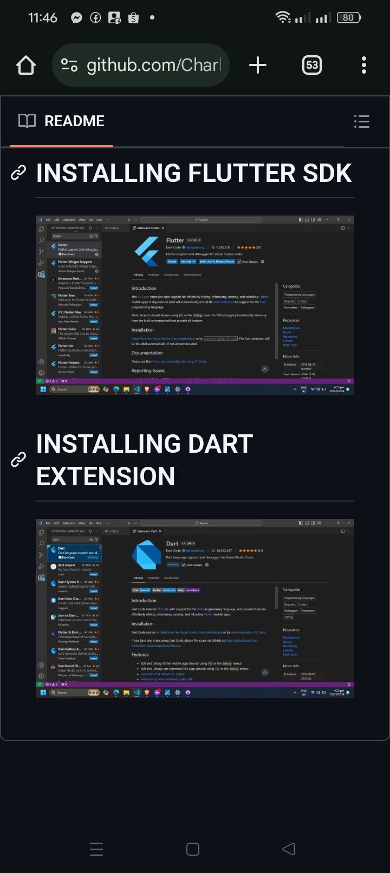

**INSTALLING DART EXTENSION**

